**PROJECT LEARNING:**

**PROBLEM STATEMENT:**

1. **KPI’s Requirements:**
2. **Total Loan Applications:** We need to calculate the total number of loan applications received during a specified period. Additionally, it is essential to monitor the Month-to-Date(MTD) Loan Applications and track changes Month-over-Month(MoM).
3. **Total Funded Amount:** Understanding the total amount of funds disbursed as loans is crucial. We also want to keep an eye on the MTD Total Funded Amount and analyze the Month-over-Month(MoM) changes in this metric.
4. **Total Amount Received:** Tracking the total amount received from borrowers is essential for assessing the bank’s cash flow and loan repayment. We should analyze the Month-to-Date(MTD) Total Amount received and observe the Month-over-Month(MoM)changes.
5. **Average Interest Rate:** Calculating the average interest rate across all loans, MTD, and monitoring the Month-over-Month(MoM)variations in interest rates will provide insights into our lending portfolio’s overall cost.
6. **Average Debt-to-Income Ratio(DTI):** Evaluating the average DTI for our borrowers helps us gauge their financial health. We need to compute the average DTI for all loans, MTD, and track Month-over-Month(MoM)fluctuations.
7. **Good Loan v Bad Loan KPI’s**

**Good Loan:**

1. **Good Loan Application Percentage**
2. **Good Loan Applications**
3. **Good Loan Funded Amount**
4. **Good Loan Total Received Amount**

**Bad Loan**

1. **Bad Loan Application Percentage**
2. **Bad Loan Applications**
3. **Bad Loan Funded Amount**
4. **Bad Loan Total Received Amount**
5. **Loan Status Grid View**

In order to gain a comprehensive overview of our lending operations and monitor the performance of loans, we aim to create a grid view report categorized by 'Loan Status.’ By providing insights into metrics such as 'Total Loan Applications,' 'Total Funded Amount,' 'Total Amount Received,' 'Month-to-Date (MTD) Funded Amount,' 'MTD Amount Received,' 'Average Interest Rate,' and 'Average Debt-to-Income Ratio (DTI),' this grid view will empower us to make data-driven decisions and assess the health of our loan portfolio.

**CHARTS**

1. **Monthly Trends by Issue Date (Line Chart):** To identify seasonality and long-term trends in lending activities
2. **Regional Analysis by State (Filled Map):** To identify regions with significant lending activity and assess regional disparities
3. **Loan Term Analysis (Donut Chart):** To allow the client to understand the distribution of loans across various term lengths.
4. **Employee Length Analysis (Bar Chart):** How lending metrics are distributed among borrowers with different employment lengths, helping us assess the impact of employment history on loan applications.
5. **Loan Purpose Breakdown (Bar Chart):** Will provide a visual breakdown of loan metrics based on the stated purposes of loans, aiding in the understanding of the primary reasons borrowers seek financing.
6. **Home Ownership Analysis (Tree Map):** For a hierarchical view of how home ownership impacts loan applications and disbursements.

**GRID**

Need for a comprehensive 'Details Dashboard' that provides a consolidated view of all the essential information within our loan data. This Details Dashboard aims to offer a holistic snapshot of key loan-related metrics and data points, enabling users to access critical information efficiently.

**Objective:**

The primary objective of the Details Dashboard is to provide a comprehensive and user-friendly interface for accessing vital loan data. It will serve as a one-stop solution for users seeking detailed insights into our loan portfolio, borrower profiles, and loan performance.

**KPI’s:**

1. **Total Loan Applications**

SELECT COUNT(id) AS Total_Loan_Application FROM bank_loan_data

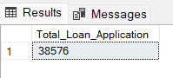

**MTD Loan Applications**

SELECT COUNT(id) AS MTD_Total_Loan_Application FROM bank_loan_data

WHERE MONTH(issue_date) = 12 AND YEAR(issue_date) = 2021

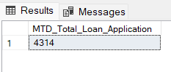

**PMTD Loan Applications**

SELECT COUNT(id) AS PMTD_Total_Loan_Application FROM bank_loan_data

WHERE MONTH(issue_date) = 11 AND YEAR(issue_date) = 2021

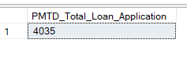

1. **Total Funded Amount:**

SELECT SUM(loan_amount) AS Total_Funded_Amount FROM bank_loan_data

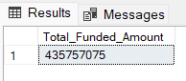

**MTD Funded Amount:**

SELECT SUM(loan_amount) AS MTD_Total_Funded_Amount FROM bank_loan_data

WHERE MONTH(issue_date) = 12 AND YEAR(issue_date) = 2021

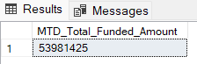

**PMTD Funded Amount:**

SELECT SUM(loan_amount) AS PMTD_Total_Funded_Amount FROM bank_loan_data

WHERE MONTH(issue_date) = 11 AND YEAR(issue_date) = 2021

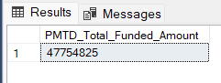

1. **Total Amount Received:**

SELECT SUM(total_payment) AS Total_Amount_Received FROM bank_loan_data

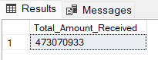

**MTD Average Interest Rate:**

SELECT SUM(total_payment) AS Total_Amount_Received FROM bank_loan_data

WHERE MONTH(issue_date) = 11 AND YEAR(issue_date) = 2021

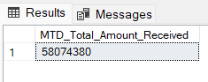

**PMTD Average Interest Rate:**

SELECT SUM(total_payment) AS Total_Amount_Received FROM bank_loan_data

WHERE MONTH(issue_date) = 12 AND YEAR(issue_date) = 2021

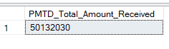

1. **Average Interest Rate:**

SELECT AVG(int_rate) * 100 AS Avg_Interest_Rate FROM bank_loan_data

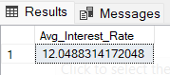

SELECT ROUND(AVG(int_rate),4) * 100 AS Avg_Interest_Rate FROM bank_loan_data

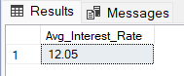

**MTD Average Interest Rate:**

SELECT AVG(int_rate) * 100 AS MTD_Avg_Interest_Rate FROM bank_loan_data

WHERE MONTH(issue_date) = 12 AND YEAR(issue_date) = 2021

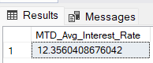

**PMTD Average Interest Rate:**

SELECT AVG(int_rate) * 100 AS PMTD_Avg_Interest_Rate FROM bank_loan_data

WHERE MONTH(issue_date) = 11 AND YEAR(issue_date) = 2021



1. **Average Debt-to-Income Ratio(DTI):**

SELECT AVG(dti)* 100 AS Average_DTI FROM bank_loan_data

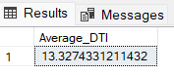

**MTD Average Interest Rate:**

SELECT AVG(dti) * 100 AS MTD_Average_DTI FROM bank_loan_data

WHERE MONTH(issue_date) = 12 AND YEAR(issue_date) = 2021



**PMTD Average Interest Rate:**

SELECT AVG(dti) * 100 AS MTD_Average_DTI FROM bank_loan_data

WHERE MONTH(issue_date) = 12 AND YEAR(issue_date) = 2021



**MoM = (**[MTD Loan Applications]-

CALCULATE(TOTALMTD(COUNT(bank_loan_data[id]), DATESMTD(DATEADD('Date'[Date],-1,MONTH))))) /

CALCULATE(TOTALMTD(COUNT(bank_loan_data[id]), DATESMTD(DATEADD('Date'[Date],-1,MONTH))))

**Good Loan v Bad Loan KPI’s**

**Good Loan:**

1. **Good Loan Application Percentage**

SELECT (COUNT(CASE WHEN loan_status = 'Fully Paid' OR loan_status = 'Current' THEN id END) * 100) / COUNT(id) AS Good_Loan_Percentage FROM bank_loan_data

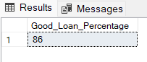

1. **Good Loan Applications**

SELECT COUNT(id) AS Good_Loan_Applications FROM bank_loan_data

WHERE loan_status = 'Fully Paid' OR loan_status = 'Current'

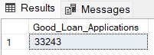

1. **Good Loan Funded Amount**

SELECT SUM(loan_amount) AS Good_Loan_Funded_Amount FROM bank_loan_data

WHERE loan_status = 'Fully Paid' OR loan_status = 'Current'



1. **Good Loan Total Received Amount**

SELECT SUM(total_payment) AS Good_Loan_Received_Amount FROM bank_loan_data

WHERE loan_status = 'Fully Paid' OR loan_status = 'Current'

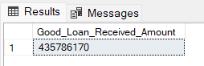

**Bad Loan**

1. **Bad Loan Application Percentage**

SELECT (COUNT(CASE WHEN loan_status = 'Charged Off' THEN id END) * 100) / COUNT(id) AS Bad_Loan_Percentage FROM bank_loan_data

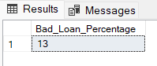

1. **Bad Loan Applications**

SELECT COUNT(id) AS Bad_Loan_Applications FROM bank_loan_data

WHERE loan_status = 'Charged Off'

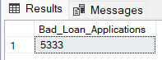

1. **Bad Loan Funded Amount**

SELECT SUM(loan_amount) AS Bad_Loan_Funded_Amount FROM bank_loan_data

WHERE loan_status = 'Charged Off'



1. **Bad Loan Total Received Amount**

SELECT SUM(total_payment) AS Bad_Loan_Received_Amount FROM bank_loan_data

WHERE loan_status = 'Charged Off'

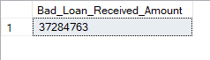

**LOAN STATUS GRID**

SELECT loan_status,

COUNT(id) AS LoanCount,

SUM(total_payment) AS Total_Amount_Received,

SUM(loan_amount) AS Total_Funded_Amount,

AVG(int_rate * 100) AS Interest_Rate,

AVG(dti * 100) AS DTI

FROM bank_loan_data GROUP BY loan_status

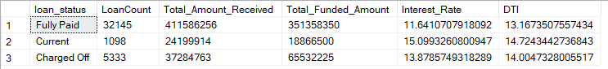

**MTD LOAN STATUS:**

SELECT loan_status,

COUNT(id) AS LoanCount,

SUM(total_payment) AS MTD_Total_Amount_Received,

SUM(loan_amount) AS MTD_Total_Funded_Amount

FROM bank_loan_data

WHERE MONTH(issue_date) = 12

GROUP BY loan_status

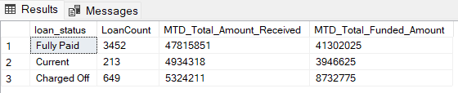

**CHARTS**

1. **Monthly Trends by Issue Date**

SELECT MONTH(issue_date) AS Month_Number,

DATENAME(MONTH, issue_date) AS Month_Name,

COUNT(id) AS Total_Loan_Applications,

SUM(loan_amount) AS Total_Funded_Amount,

SUM(total_payment) AS Total_Amount_Received

FROM bank_loan_data

GROUP BY MONTH(issue_date), DATENAME(MONTH, issue_date)

ORDER BY MONTH(issue_date)

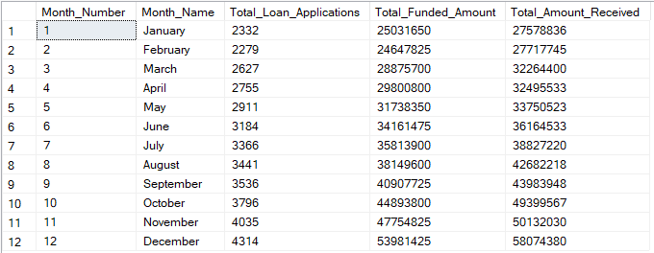

1. **Regional Analysis by State**

SELECT address_state,

COUNT(id) AS Total_Loan_Applications,

SUM(loan_amount) AS Total_Funded_Amount,

SUM(total_payment) AS Total_Received_Amount

FROM bank_loan_data

GROUP BY address_state

ORDER BY COUNT(id) DESC

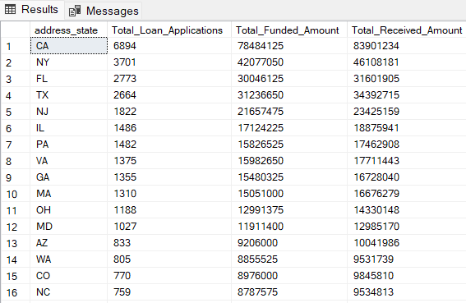

1. **Loan Term Analysis**

SELECT term AS Term,

COUNT(id) AS Total_Loan_Applications,

SUM(loan_amount) AS Total_Funded_Amount,

SUM(total_payment) AS Total_Received_Amount

FROM bank_loan_data

GROUP BY term

ORDER BY term

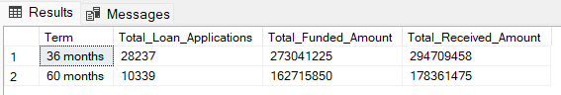

1. **Employee Length Analysis:**

SELECT emp_length AS Employee_Length,

COUNT(id) AS Total_Loan_Applications,

SUM(loan_amount) AS Total_Funded_Amount,

SUM(total_payment) AS Total_Received_Amount

FROM bank_loan_data

GROUP BY emp_length

ORDER BY COUNT(id) desc

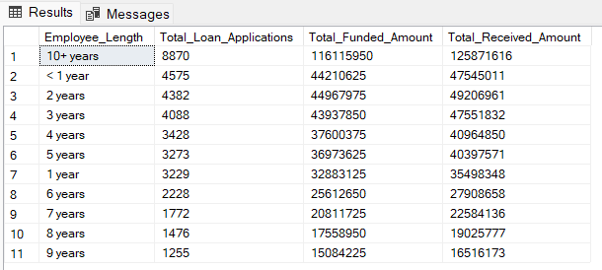

1. **Loan Purpose Breakdown:**

SELECT purpose AS Loan_Purpose,

COUNT(id) AS Total_Loan_Applications,

SUM(loan_amount) AS Total_Funded_Amount,

SUM(total_payment) AS Total_Received_Amount

FROM bank_loan_data

GROUP BY purpose

ORDER BY COUNT(id) DESC

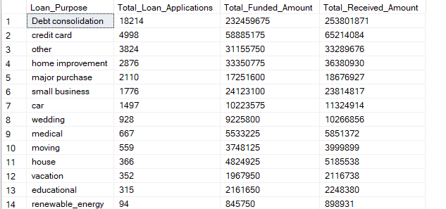

1. **Home Ownership Analysis:**

SELECT home_ownership AS Home_Ownership,

COUNT(id) AS Total_Loan_Applications,

SUM(loan_amount) AS Total_Funded_Amount,

SUM(total_payment) AS Total_Received_Amount

FROM bank_loan_data

GROUP BY home_ownership

ORDER BY COUNT(id) DESC

